Atwood Machine-Frictionless Case with Light Pulley

Objectives: Find the acceleration of a two-body system, Atwood machine, using two methods:

Method #1: Apply Newton’s 2nd Law for a system:
Net External Force = Total Mass x Acceleration of the system

Method #2: Apply one of the Kinematics Equations:
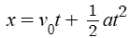

Method #1 Find the acceleration of Atwood machine, a two-body system, by Newton’s 2nd Law:

Physics Laws and Mathematical Calculations:
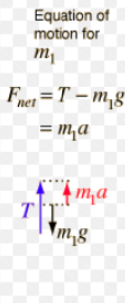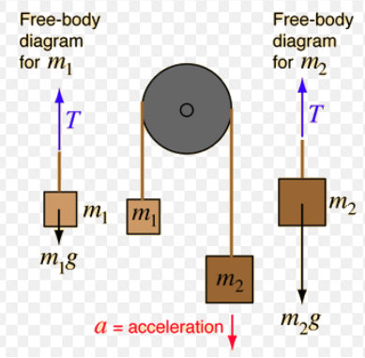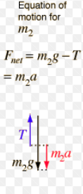
For this frictionless case, tension T is the same on both sides, and both tensions are internal forces (action-reaction forces) for the two-block system. The net external force of the system is:
The total mass of the system is:
By Newton’s 2nd Law for a system:
Net External Force = Total Mass x Acceleration of the system

The acceleration of the system is:
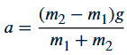
Apply Newton’s 2nd law Equation for either above blocks, the tension in the string is:
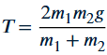

Method #2 Find the acceleration of an Atwood machine, a two-body system, by Kinematics:

- Release the larger mass of the Atwood machine from rest. Let it fall to a distance y. Measure the time taken t for falling this distance. Apply the kinematics equation:
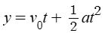
Since the initial velocity is 0(the blocks started from rest), solve for a, the acceleration of the system is:
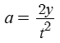
Lab Tools: Pulleys, stand, threads, masses, timer, metersticks, scale for mass

Procedure:
- Set up an Atwood machine: Attach a larger mass ${m_{2}}_{}$at one end of the string.
- Measure the larger mass ${m_{2}}_{}$= __________. Write your result in kg: ${m_{2}}_{}$=________kg
- Release the larger mass of the Atwood machine from rest, let it fall to a distance y

- measure the distance y = __________. Write your result in meters: y = _________ meters.
- Measure the time taken t for falling this distance three times:

t1= _________, t2=_________, t3=________,

Then calculate the average of the time taken: t average=___________
6. Apply Kinematics to find the acceleration of the system: , ___________

7. Mass the smaller mass ${m_{1}}_{}$=___________Write your result in kg: ${m_{1}}_{}$ =____________kg
8. Apply Newton’s 2nd Law on a system to obtain acceleration:
___________________

Analysis:
- Find the difference of the two accelerations:
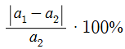____________________

- What could be the factors in the lab to cause the difference in the measurements?

